Cloud computing

**Cloud computing refers to the use of hosted services, such as data storage, servers, databases, networking, and software over the internet. The data is stored on physical servers, which are maintained by a cloud service provider. Computer system resources, especially data storage and computing power, are available on-demand, without direct management by the user in cloud computing.**

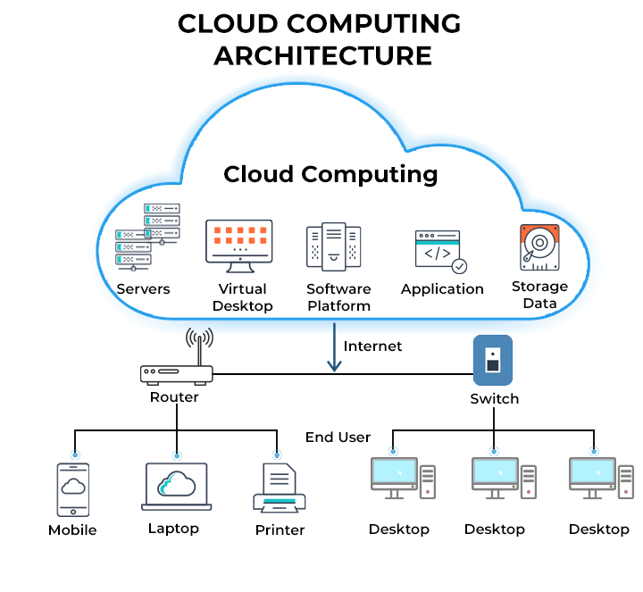

**Cloud Computing Architecture**

Instead of storing files on a storage device or hard drive, a user can save them on cloud, making it possible to access the files from anywhere, as long as they have access to the web. The services hosted on cloud can be broadly divided into infrastructure-as-a-service (IaaS), platform-as-a-service (PaaS), and software-as-a-service (SaaS). Based on the deployment model, cloud can also be classified as public, private, and hybrid cloud.

Further, cloud can be divided into two different layers, namely, front-end and back-end. The layer with which users interact is called the front-end layer. This layer enables a user to access the data that has been stored in cloud through cloud computing software.

The layer made up of software and hardware, i.e., the computers, servers, central servers, and databases, is the back-end layer. This layer is the primary component of cloud and is entirely responsible for storing information securely. To ensure seamless connectivity between devices linked via cloud computing, the central servers use a software called[middleware](https://community.spiceworks.com/) that acts as a bridge between the database and applications.

Cloud computing is the delivery of on-demand computing services—like servers, storage, databases, software, and analytics—over the internet ("the cloud") to offer faster innovation, flexibility, and scalability. Instead of owning and managing their own physical IT infrastructure, individuals and businesses access these resources from providers and typically pay only for what they use. This model reduces costs, offers elastic scaling, and makes computing resources accessible from virtually anywhere with an internet connection.

Benefits of cloud computing

Agility

The cloud gives you easy access to a broad range of technologies so that you can innovate faster and build nearly anything that you can imagine. You can quickly spin up resources as you need them–from infrastructure services, such as compute, storage, and databases, to Internet of Things, machine learning, data lakes and analytics, and much more.

You can deploy technology services in a matter of minutes, and get from idea to implementation several orders of magnitude faster than before. This gives you the freedom to experiment, test new ideas to differentiate customer experiences, and transform your business.

Elasticity

With cloud computing, you don’t have to over-provision resources up front to handle peak levels of business activity in the future. Instead, you provision the amount of resources that you actually need. You can scale these resources up or down to instantly grow and shrink capacity as your business needs change.

Cost savings

The cloud allows you to trade fixed expenses (such as data centers and physical servers) for variable expenses, and only pay for IT as you consume it. Plus, the variable expenses are much lower than what you would pay to do it yourself because of the economies of scale.

Deploy globally in minutes

With the cloud, you can expand to new geographic regions and deploy globally in minutes. For example, AWS has infrastructure all over the world, so you can deploy your application in multiple physical locations with just a few clicks. Putting applications in closer proximity to end users reduces latency and improves their experience.

## Types of Cloud Computing

Cloud Computing means storing and accessing data or applications over the Internet. This can be done in three ways 1. Public Cloud Computing 2. Private Cloud Computing 3. Hybrid cloud Computing. Below we will look at their advantages and disadvantages. There are three types of cloud computing.

**Types of Cloud Computing**

* Public Cloud Computing
* Private Cloud Computing
* Hybrid Cloud Computing

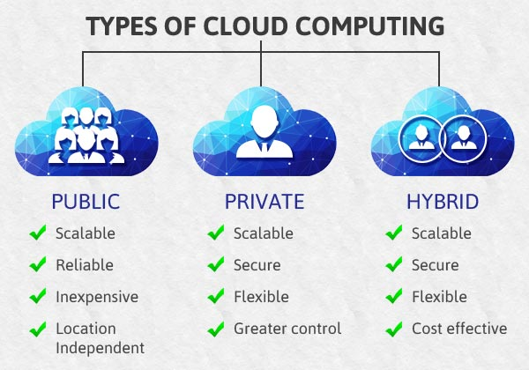

**Public Cloud Computing**

A cloud platform that is based on standard cloud computing model in which service provider offers resources, applications storage to the customers over the internet is called as public cloud computing. The hardware resources in public cloud are shared among similar users and accessible over a public network such as the internet. Most of the applications that are offered over internet such as Software as a Service (SaaS) offerings such as cloud storage and online applications uses Public Cloud Computing platform. Budget conscious startups, SMEs not keen on high level of security features looking to save money can opt for Public Cloud Computing.

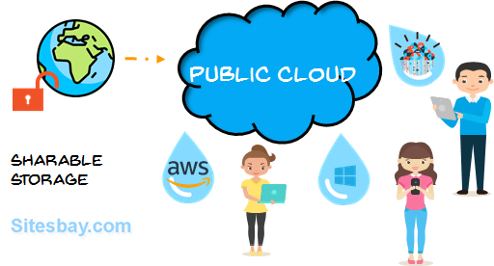

**Advantage of Public Cloud Computing**

* It offers greater scalability
* Its cost effectiveness helps you save money.
* It offers reliability which means no single point of failure will interrupt your service.
* Services like SaaS, (Paas), (Iaas) are easily available on Public Cloud platform as it can be accessed from anywhere through any Internet enabled devices.
* It is location independent – the services are available wherever the client is located.

**Disadvantage of Public Cloud Computing**

* No control over privacy or security
* Cannot be used for use of sensitive applications
* Lacks complete flexibility as the platform depends on the platform provider
* No stringent protocols regarding data management

**Private Cloud Computing**

A cloud platform in which a secure cloud based environment with dedicated storage and hardware resources provided to a single organization is called Private Cloud Computing. The Private cloud can be either hosted within the company or outsourced to a trusted and reliable third-party vendor. It offers company a greater control over privacy and data security. The resources in case of private cloud are not shared with others and hence it offer better performance compared to public cloud. The additional layers of security allow company to process confidential data and sensitive work in the private cloud environment.

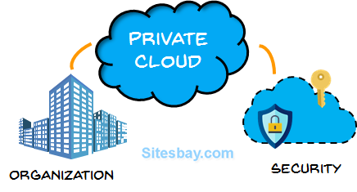

**Advantage of Private Cloud Computing**

* Offers greater Security and Privacy
* Offers more control over system configuration as per the company’s need
* Greater reliability when it comes to performance
* Enhances the quality of service offered by the clients
* Saves money

**Disadvantage of Private Cloud**

* Expensive when compared to public cloud
* Requires IT Expertise

**Hybrid Cloud Computing**

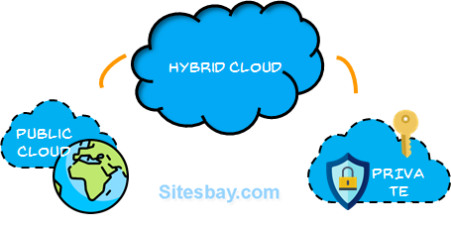Hybrid Cloud computing allows you to use combination of both public and private cloud. This helps companies to maximize their efficiency and deliver better performance to clients.In this model companies can use public cloud for transfer of non-confidential data and switch on to private cloud in case of sensitive data transfer or hosting of critical applications. This model is gaining prominence in many business as it gives benefits of both the model.

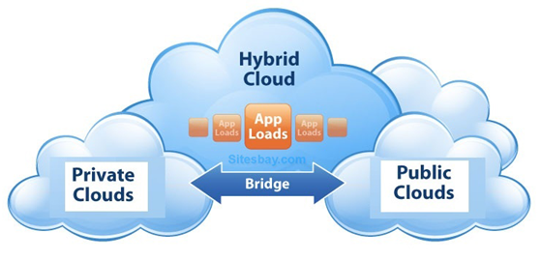

**Advantage of Hybrid Cloud Computing**

* It is scalable
* It is cost efficient
* Offers better security
* Offers greater flexibility

**Disadvantage of Hybrid Cloud Computing**

* Infrastructure Dependency
* Possibility of security breach through public cloud

Deployment Models

These models determine the ownership and accessibility of the cloud environment.

* [**Public Cloud**](https://www.google.com/search?sca_esv=8fb985a9e177f272&q=Public+Cloud&sa=X&ved=2ahUKEwji4Y_h_tyPAxXL1jgGHXOwAq0QxccNegUIgQMQAQ&mstk=AUtExfACNk9vKazh4Agd03gjZKDyauFcO_EzJKfdh8mdN0HZTuScVsx9BfpWpvXlBqE_CwKKSLKMevWC3LXYNhUhIAgRLA1_ZBuN_9_RTrl0bM1Bvl5-7mebrCxE1yRLDeRmKLQ&csui=3)**:**

Cloud services are offered over the internet to anyone who wants to buy them and are hosted by a third-party provider.

* [**Private Cloud**](https://www.google.com/search?sca_esv=8fb985a9e177f272&q=Private+Cloud&sa=X&ved=2ahUKEwji4Y_h_tyPAxXL1jgGHXOwAq0QxccNegUI_AIQAQ&mstk=AUtExfACNk9vKazh4Agd03gjZKDyauFcO_EzJKfdh8mdN0HZTuScVsx9BfpWpvXlBqE_CwKKSLKMevWC3LXYNhUhIAgRLA1_ZBuN_9_RTrl0bM1Bvl5-7mebrCxE1yRLDeRmKLQ&csui=3)**:**

A cloud environment used exclusively by a single organization, offering more control and security than a public cloud.

* [**Hybrid Cloud**](https://www.google.com/search?sca_esv=8fb985a9e177f272&q=Hybrid+Cloud&sa=X&ved=2ahUKEwji4Y_h_tyPAxXL1jgGHXOwAq0QxccNegUI_wIQAQ&mstk=AUtExfACNk9vKazh4Agd03gjZKDyauFcO_EzJKfdh8mdN0HZTuScVsx9BfpWpvXlBqE_CwKKSLKMevWC3LXYNhUhIAgRLA1_ZBuN_9_RTrl0bM1Bvl5-7mebrCxE1yRLDeRmKLQ&csui=3)**:**

A mix of public and private cloud environments that are integrated to share data and applications between them, allowing businesses to leverage the strengths of both.

* [**Community Cloud**](https://www.google.com/search?sca_esv=8fb985a9e177f272&q=Community+Cloud&sa=X&ved=2ahUKEwji4Y_h_tyPAxXL1jgGHXOwAq0QxccNegUIgwMQAQ&mstk=AUtExfACNk9vKazh4Agd03gjZKDyauFcO_EzJKfdh8mdN0HZTuScVsx9BfpWpvXlBqE_CwKKSLKMevWC3LXYNhUhIAgRLA1_ZBuN_9_RTrl0bM1Bvl5-7mebrCxE1yRLDeRmKLQ&csui=3)**:**

Similar to a private cloud, but is shared by several organizations that have common interests, such as a specific industry.

* [**Multi-cloud**](https://www.google.com/search?sca_esv=8fb985a9e177f272&q=Multicloud&sa=X&ved=2ahUKEwji4Y_h_tyPAxXL1jgGHXOwAq0QxccNegUI-wIQAQ&mstk=AUtExfACNk9vKazh4Agd03gjZKDyauFcO_EzJKfdh8mdN0HZTuScVsx9BfpWpvXlBqE_CwKKSLKMevWC3LXYNhUhIAgRLA1_ZBuN_9_RTrl0bM1Bvl5-7mebrCxE1yRLDeRmKLQ&csui=3)**:**

Involves the use of two or more different public or private cloud services.

Service Models

These models describe the level of service and management provided to the end-user.

* [**Infrastructure as a Service (IaaS)**](https://www.google.com/search?sca_esv=8fb985a9e177f272&q=Infrastructure+as+a+Service+%28IaaS%29&sa=X&ved=2ahUKEwji4Y_h_tyPAxXL1jgGHXOwAq0QxccNegUI_gIQAQ&mstk=AUtExfACNk9vKazh4Agd03gjZKDyauFcO_EzJKfdh8mdN0HZTuScVsx9BfpWpvXlBqE_CwKKSLKMevWC3LXYNhUhIAgRLA1_ZBuN_9_RTrl0bM1Bvl5-7mebrCxE1yRLDeRmKLQ&csui=3)**:**

Provides basic computing infrastructure, like virtual servers, storage, and networking, over the internet.

* [**Platform as a Service (PaaS)**](https://www.google.com/search?sca_esv=8fb985a9e177f272&q=Platform+as+a+Service+%28PaaS%29&sa=X&ved=2ahUKEwji4Y_h_tyPAxXL1jgGHXOwAq0QxccNegUIgAMQAQ&mstk=AUtExfACNk9vKazh4Agd03gjZKDyauFcO_EzJKfdh8mdN0HZTuScVsx9BfpWpvXlBqE_CwKKSLKMevWC3LXYNhUhIAgRLA1_ZBuN_9_RTrl0bM1Bvl5-7mebrCxE1yRLDeRmKLQ&csui=3)**:**

Offers a platform and environment for developing, running, and managing applications, without the complexity of managing the underlying infrastructure.

* [**Software as a Service (SaaS)**](https://www.google.com/search?sca_esv=8fb985a9e177f272&q=Software+as+a+Service+%28SaaS%29&sa=X&ved=2ahUKEwji4Y_h_tyPAxXL1jgGHXOwAq0QxccNegUI_QIQAQ&mstk=AUtExfACNk9vKazh4Agd03gjZKDyauFcO_EzJKfdh8mdN0HZTuScVsx9BfpWpvXlBqE_CwKKSLKMevWC3LXYNhUhIAgRLA1_ZBuN_9_RTrl0bM1Bvl5-7mebrCxE1yRLDeRmKLQ&csui=3)**:**

Delivers fully functional software applications over the internet on a subscription basis, like email or CRM.

* [**Serverless Computing**](https://www.google.com/search?sca_esv=8fb985a9e177f272&q=Serverless+Computing&sa=X&ved=2ahUKEwji4Y_h_tyPAxXL1jgGHXOwAq0QxccNegUIggMQAQ&mstk=AUtExfACNk9vKazh4Agd03gjZKDyauFcO_EzJKfdh8mdN0HZTuScVsx9BfpWpvXlBqE_CwKKSLKMevWC3LXYNhUhIAgRLA1_ZBuN_9_RTrl0bM1Bvl5-7mebrCxE1yRLDeRmKLQ&csui=3)**:**

A model where the cloud provider manages the servers, allowing developers to focus solely on writing and deploying code without worrying about server infrastructure.